- Hardware and wiring
- Arduino uno x1  - Breadboard x1  - 4x4 keypad x1  - servo motor x1  - Red LED x1  - Green LED x1  - 220 ohm x2  - jumper Cable | 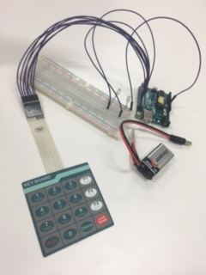
>>> replace 2 LEDs by Servo motor  - red wire for VCC  - black wire for GND  - Orange wire for signal  - A Continuous rotation servo motor >>it will not meet the purpose | 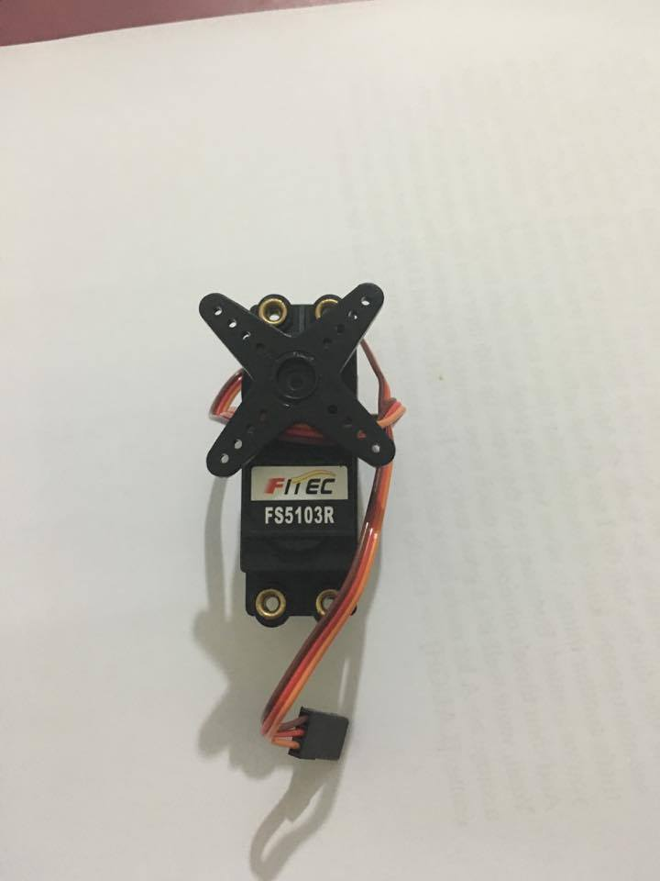
>>>change the last one by this | 